**Description of three observable trends based on the data.**

**Homework 04 – Pandas**

**Dan Boulden**

I chose option 1: “Heroes of Pymoli.” This is data from a free game that then has additional purchasable items within the game. Because one of the games revenue streams is the in game purchase of items we have been tasked with looking into the data for “meaningful insights.” We can infer from this task that management is interested in gaining an understanding of what they can do to increase this revenue stream.

This is a list of some of the trends that I see in the data (not all trends, but several)

**Where to spend the advertising dollars:**

The bulk of the players (44.79%) are between 20 and 24 years old and they are spending the third highest amount per person ($4.32). This would mean that this demographic is probably going to be the easiest to grow. However, if we could grow the 35 to 39 demographic, then each person in 35-39 is worth $0.44 more on average. This means that the 35-39 generates 10% more dollars per person. We do not have advertising information on this project, but I would like to see what the advertising demographics are showing. If we are putting a lot of money towards the 20-24’s, it seems to be paying off, but what are we spending to get a 20-24 vs a 35-39? If it is less than 10% then the better money might be spent of 35-39, if it will generate more players. However, the players over 40 are generating the lowest sales in each category and should not be advertised to.

**Number of items needed:**

Looking at the top spenders we quickly see that three items seems to be the current limit on what people will buy. While we do have 3 people who bought 4 or 5 items, those are clearly outliers. Most people are only buying 2 items or less. So the game may need to make the items more useful, expire, or become obsolete in higher player levels so that players want to buy more or replenish them. It appears that new users can be counted on for buying a couple of items, but not a continued revenue stream.

**Most popular items are not that popular:**

“Oathbreaker, Last Hope of the Breaking Storm”, item #178 is out selling the next highest item by 25%. However, it looks like none of the items are selling to a lot of players. There are 576 players, but the top selling item only accounts for 2.1% of the item sales (by volume). This may indicate that the items are too specialized, or that the choices are too general. In other words, we would want to have items that are very popular so that we could in-game advertise them so that the players would see them and understand that they need to get one to do better.

**The easy ones:**

* More men play the game by a very large percentage (84%)
  + However, men spend the least amount of money on average
* More people between the ages of 20 and 24 play the game
  + In fact, the age of players creates a bell curve
  + This chart is from under 10 to over 40
  + 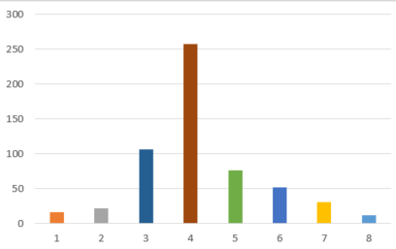
* The above is a very quick chart to illustrate the bell curve. It was not done in Pandas.